

Foundations of Programming

Assignment No.: 19
PROBLEM STATEMENT: Create Structure EMPLOYEE for storing details (Name, Designation, gender, Date of Joining and Salary). Define function members to compute a) total number of employees in an organization b) count of male and female employee c) Employee with salary more than 10,000 d) Employee with designation “Asst Manager”

OBJECTIVE:

- To understand the use of structures in C programming.
- To store and manage employee records using structures.
- To perform operations such as counting and filtering employee data

THEORY:
In the C programming language, a structure is a user-defined data type that groups related variables of different data types under a single name. Structures are widely used for representing records such as employee information. In this program, a structure named EMPLOYEE is created to store employee details such as name, designation, gender, date of joining, and salary. By using loops and conditional statements, the program can calculate the total number of employees, count male and female employees, find employees whose salary is greater than 10,000, and display employees having the designation 'Asst Manager'.
PLATFORM: Linux
ALGORITHM:

Step 1: Start
Step 2: Define structure EMPLOYEE with fields: name, designation, gender, doj, salary
Step 3: Input number of employees n
Step 4: For each employee i from 0 to n-1, accept all fields
Step 5: Count total = n
Step 6: Traverse array, count gender=='M' for males and gender=='F' for females
Step 7: Traverse array, print name where salary > 10000
Step 8: Traverse array, print name where designation == 'Asst Manager'
Step 9: Display all results
Step 10: Stop

FLOWCHART:
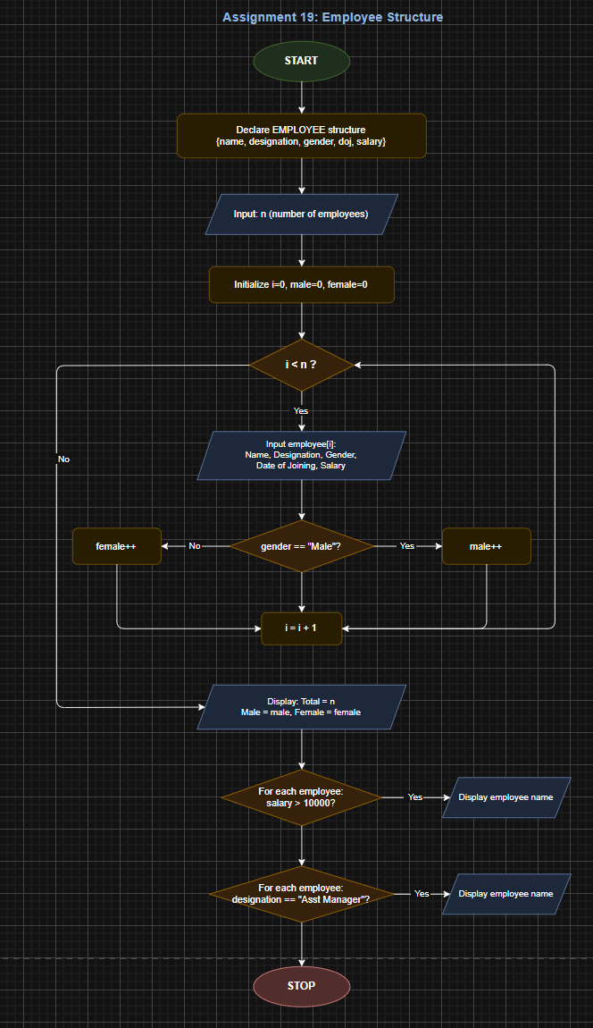
CODE:
#include <stdio.h>
#include <string.h>

struct Employee {
char name[50];
char designation[50];
char gender;
char doj[15];
float salary;
};

int totalEmployees(int n) {
return n;
}

void countGender(struct Employee emp[], int n) {
int male = 0, female = 0;
for (int i = 0; i < n; i++) {
if (emp[i].gender == 'M' || emp[i].gender == 'm')
male++;
else if (emp[i].gender == 'F' || emp[i].gender == 'f')
female++;
}
printf("\nMale Employees : %d", male);
printf("\nFemale Employees : %d\n", female);
}

void salaryAbove10k(struct Employee emp[], int n) {
int found = 0;
printf("\nEmployees with Salary > 10,000:\n");
printf("%-20s %-20s %-8s %-15s %-10s\n",
"Name", "Designation", "Gender", "Date of Joining", "Salary");
printf("----------------------------------------------------------------------\n");
for (int i = 0; i < n; i++) {
if (emp[i].salary > 10000) {
printf("%-20s %-20s %-8c %-15s %-10.2f\n",
emp[i].name, emp[i].designation,
emp[i].gender, emp[i].doj, emp[i].salary);
found++;
}
}
if (found == 0)
printf("No employees found with salary above 10,000.\n");
}

void findAsstManager(struct Employee emp[], int n) {
int found = 0;
printf("\nEmployees with Designation 'Asst Manager':\n");
printf("%-20s %-20s %-8s %-15s %-10s\n",
"Name", "Designation", "Gender", "Date of Joining", "Salary");
printf("----------------------------------------------------------------------\n");
for (int i = 0; i < n; i++) {
if (strcmp(emp[i].designation, "Asst Manager") == 0) {
printf("%-20s %-20s %-8c %-15s %-10.2f\n",
emp[i].name, emp[i].designation,
emp[i].gender, emp[i].doj, emp[i].salary);
found++;
}
}
if (found == 0)
printf("No employees found with designation 'Asst Manager'.\n");
}

int main() {
int n;

printf("Enter number of employees: ");
scanf("%d", &n);

struct Employee emp[n];

// Input employee details
for (int i = 0; i < n; i++) {
printf("\n--- Enter details for Employee %d ---\n", i + 1);

printf("Name : ");
scanf(" %[^\n]", emp[i].name);

printf("Designation : ");
scanf(" %[^\n]", emp[i].designation);

printf("Gender (M/F) : ");
scanf(" %c", &emp[i].gender);

printf("Date of Joining : ");
scanf(" %[^\n]", emp[i].doj);

printf("Salary : ");
scanf("%f", &emp[i].salary);
}

int choice;
do {
printf("\n========= MENU =========\n");
printf("1. Total Employees\n");
printf("2. Male & Female Count\n");
printf("3. Salary > 10,000\n");
printf("4. Designation: Asst Manager\n");
printf("5. Exit\n");
printf("Enter choice: ");
scanf("%d", &choice);

switch (choice) {
case 1:
printf("\nTotal Employees: %d\n", totalEmployees(n));
break;
case 2:
countGender(emp, n);
break;
case 3:
salaryAbove10k(emp, n);
break;
case 4:
findAsstManager(emp, n);
break;
case 5:
printf("Exiting...\n");
break;
default:
printf("Invalid choice!\n");
}
} while (choice != 5);

return 0;
}

INPUT: Employee details such as Name, Designation, Gender, Date of Joining and Salary.

OUTPUT: Displays total number of employees, count of male and female employees, employees with salary greater than 10,000, and employees with designation 'Asst Manager'.
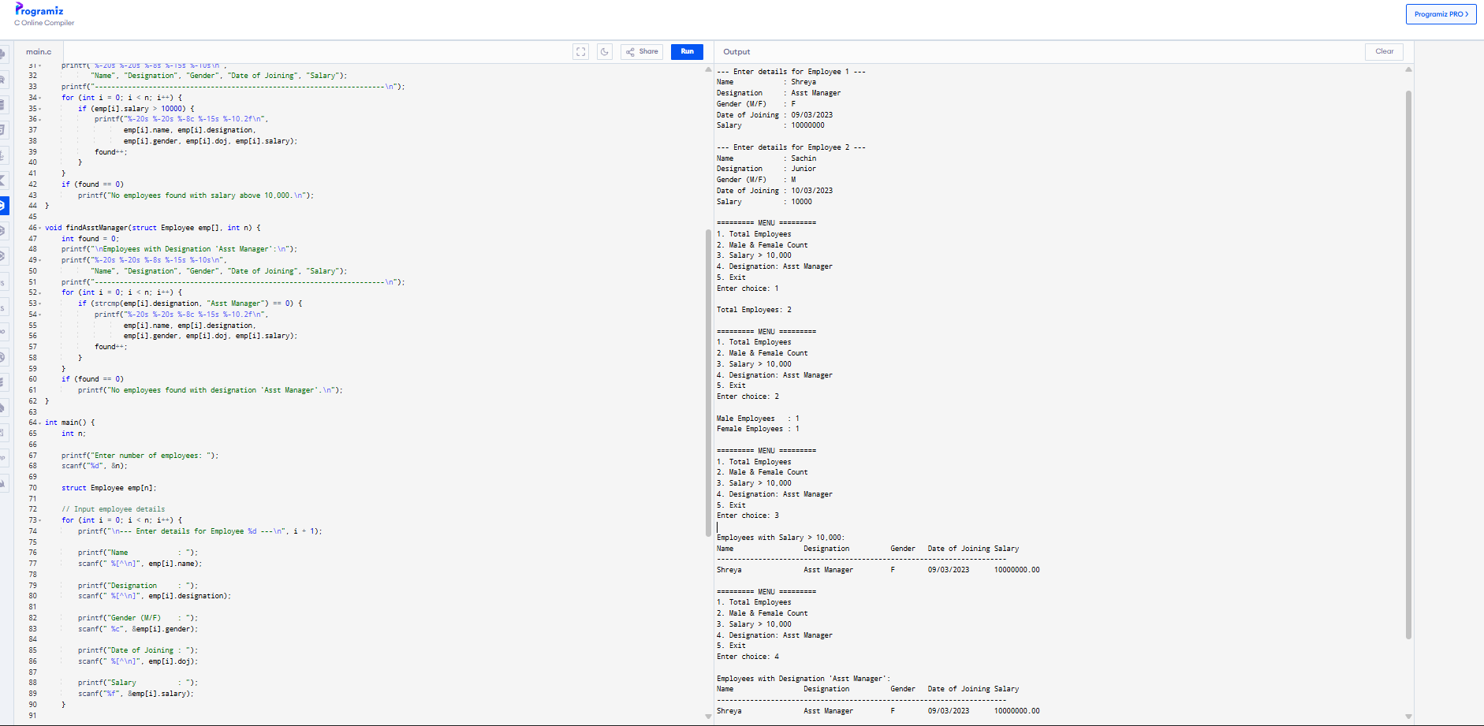
CONCLUSION: Thus, the C program successfully demonstrates the use of structures to store employee details and perform various operations such as counting employees, identifying employees with salary greater than 10,000, and displaying employees with the designation 'Asst Manager'.

